CS23B2004
Tarun Mamillapalli

Q1) The return address of the samp_func will be stored in the lr of the frame pertaining to the samp_func. So i have displayed the picture of the content of the lr.

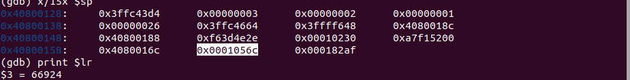
Q2) The content is 0x10565c of the lr, so I first calculated the frame size by the frame pointer and stack pointer of the samp_func(), i subtracted it, it was turning out to be 0x40800160 – 0x40800128 which is 38 in base 16 that is 56 bytes , so we will require 14 words, so I wrote
x/14x $sp, to access all the words of that frame.
Now, at 0x4080015c it displayed the lr content.
So this is the address where the lr is stored in the frame of the stack pertaining to samp_func();

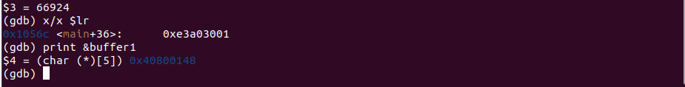
Q3) I simply used the print &buffer1, and it displayed the address as 0x40800148, it makes sense as it falls between the frame pointer and stack pointer of the samp_func();p

Q4) The difference in the start of buffer1 from lr is 0x4080015c-0x 0x40800148 which is 08 in base 16 or 8 in base 10, it is basically separated by two words !!!.

